Science Study Guide:
Weather (2nd Grade Only) and Human Body (Skeletal System - 3rd Grade Only)

Part 1: Students will identify the following terms. (50 points)

water vapor:Tiny drops of water that escape into the air
evaporation: The process of water escaping into the air when it is heated.
condensation: When water vapor meets cooler air. This is how clouds form.
precipitation: Water that falls to the ground in liquid or solid form.
The Water Cycle:
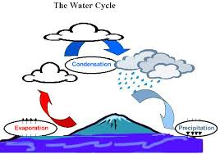
The process of water vapor rising from the ground and meeting the cold air above. Tiny drops in the clouds come together and get heavier, they fall as rain. Then, again, heated water vapor rises from the ground.
Cirrus clouds:
thin wispy, high-level clouds
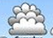
Cumulus clouds: low-level clouds;
puffy on top with flat bottoms like a dome
Stratus clouds:
flat, layered clouds that are low-lying.
They sometimes cover the sky with a blanket to cause a gray day.

Part 2: Writing Prompt
Students will choose from 2 of the following. (50 points)

- Pretend you are a drop of water. Describe your journey through the water cycle.
- Describe a class experiment and what you observed. Use the words evaporation, condensation and/or precipitation in your description.
- Pick a cloud type (cirrus, cumulus, or stratus cloud). Write 2 or 3 clues that will help me figure out which type you picked.

Human Body (Skeletal System- 3rd Grade Only)

Part 1: Student will identify/explain the following terms/concepts: (50 points)

- Our bones provide support for our body.
- Ball and socket joint: Made up of the round end of one bone fitting into a small cup-like area of another bone.
- Hinge joint: Your elbows and knees each have hinge joints, which let you bend and then straighten your arms and legs.
- There are 206 bones in our body.
- Ligaments: Connect bones to each other.
- Bones are not solid. This makes bone light and easier for us to move around.
- Cartilage: Cushions of soft bone.
- Bone marrow: The jelly-like material inside of a bone. This is where new blood is made.

Label diagram:
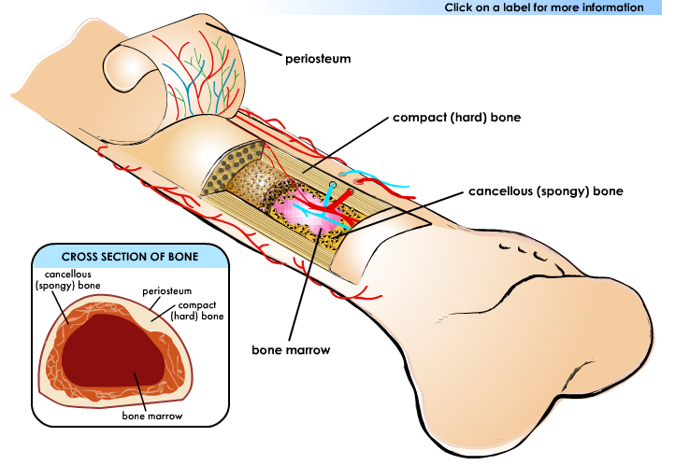

Part 2: Writing Prompt (50 points)
Students will choose from 2 of these writing prompts.

- Babies have more bones than adults. Please explain why in 2-3 sentences.
- Choose a joint in our skeletal system. Write 2-3 clues that will help me figure out which joint you picked.
- Pretend you are a bone. List and describe all of your layers.

